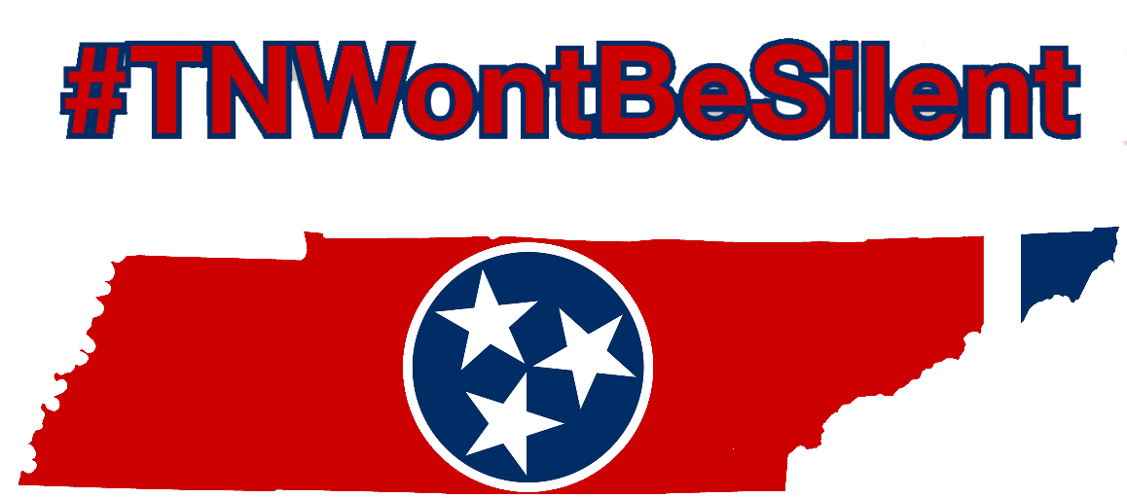

Below are some examples that your organization or business can post on social media. They can be copy and pasted for the post or you can record someone with your organization and post the video.

- The key to preventing suicide is education. Learn the statistics associated with suicide and the warning signs often displayed. By being educated on this Silent Epidemic, you could help save a life. Learn more at www.TNWontBeSilent.com #TNWontBeSilent
- Each day, we lose 3 Tennesseans to suicide. #TNWontBeSilent about the epidemic of suicide and I challenge you to do the same! Visit, www.TNWontBeSilent.com to learn how to could make a difference in someone’s life today. #TNWontBeSilent
- Would you know how to recognize or respond if friend is struggling with thoughts of suicide? I am pledging to not be silent and you can too! Visit www.TNWontBeSilent.com and find out more. #TNWontBeSilent
- Learn the warning signs associated with suicide. Suicide is preventable. #TNWontBeSilent
- Suicide is one of the leading causes of preventable death in our nation. Learn how you can help www.TNWontBeSilent.com #TNWontBeSilent
- We have joined as on of the Collaborative Partners with #TNWontBeSilent and we are going to raise the conversation about suicide prevention. Join us at www.TNWontBeSilent.com
- Raise the national conversation on #suicideprevention. Visit www.iwontbesilent.com #iwontbesilent
- In 2017, we lost 127 more lives to suicide than motor vehicle accidents in Tennessee. That is why we joined #TNWontBeSilent. Help us raise the level of conversation on suicide prevention. www.TNWontBeSilent.com

